MINISTRY OF SCIENCE AND EDUCATION NATIONAL TECHNICAL UNIVERSITY “KHARKIV POLYTECHNIC INSTITUTE”

DEPARTMENT OF SOFTWARE ENGINEERING AND MANAGEMENT INFORMATION TECHNOLOGIES

Report from lab#3

Discipline “Fundamentals of Software Engineering”

Executed by: Student of group 1.КН.201.8г

CHUKWU IRELE AMORIN

Checked by: Senior lecturer

K.V. Melnik

Kharkiv

2018

Goal: To obtain basic experience and knowledge to work with

project tracking system

Tasks:

1. Register on the free xp-dev.com account.

2. Create new project.

3. Add new user to project.

4. Create Iterations and user stories according to previous labs. Add task to

implementation of user story. Assign tasks to users of you team.

5. Work with svn repository.

6. Prepare the report of the work.

Task: create new project:

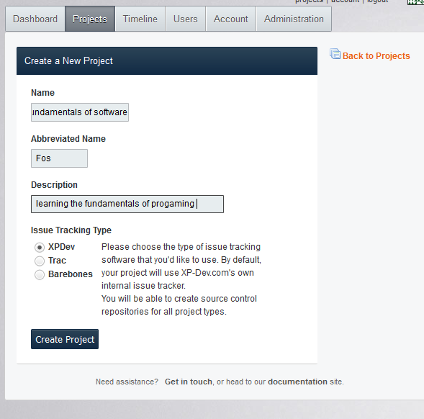

3. Add new user to project.

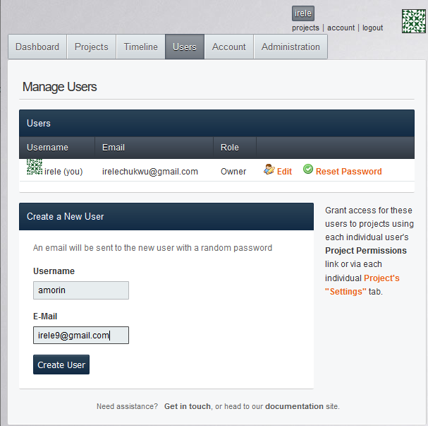

Iterations:

Requirements gathering:

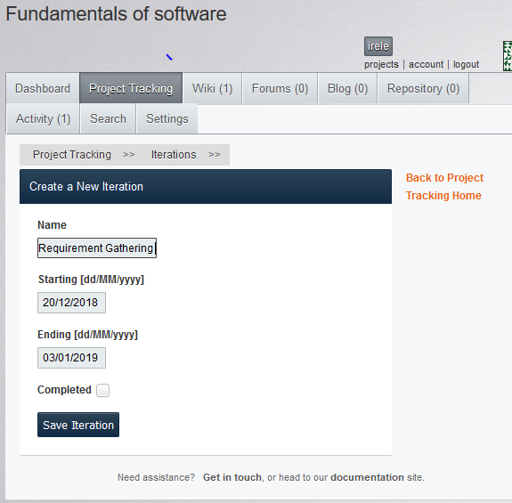

Requirements gathering: story

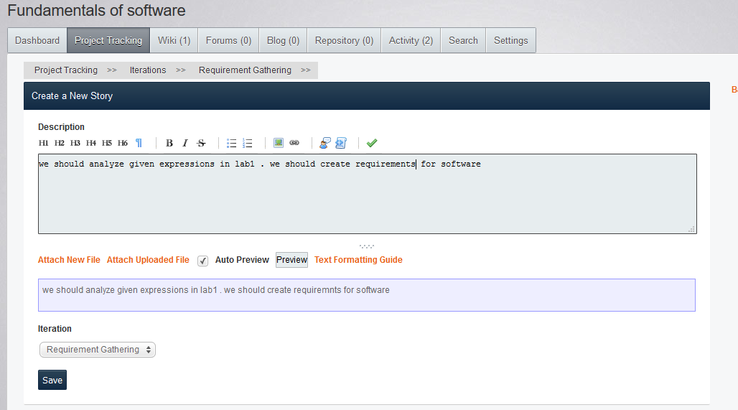

Requirements gathering task:

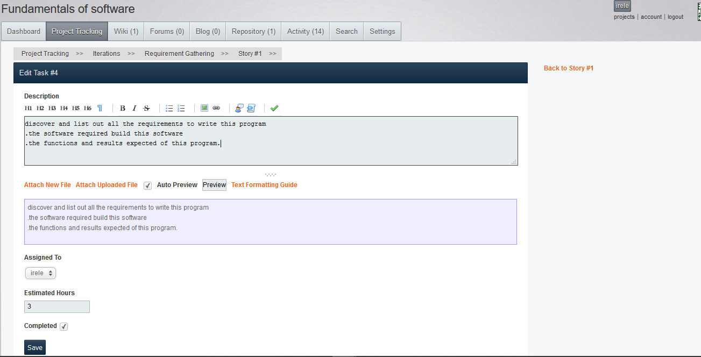

Iteration 2 : System Analysis.

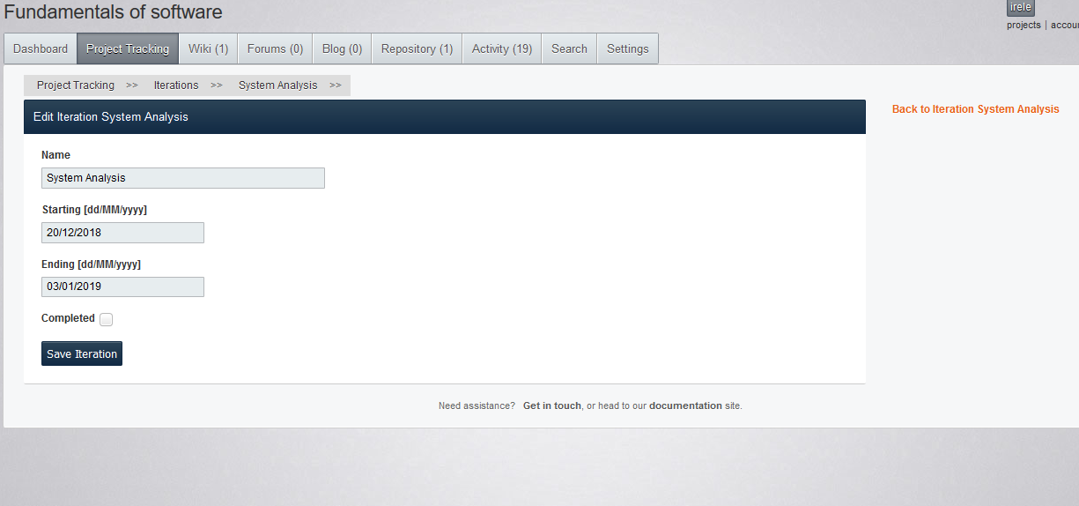

System Analysis Task:

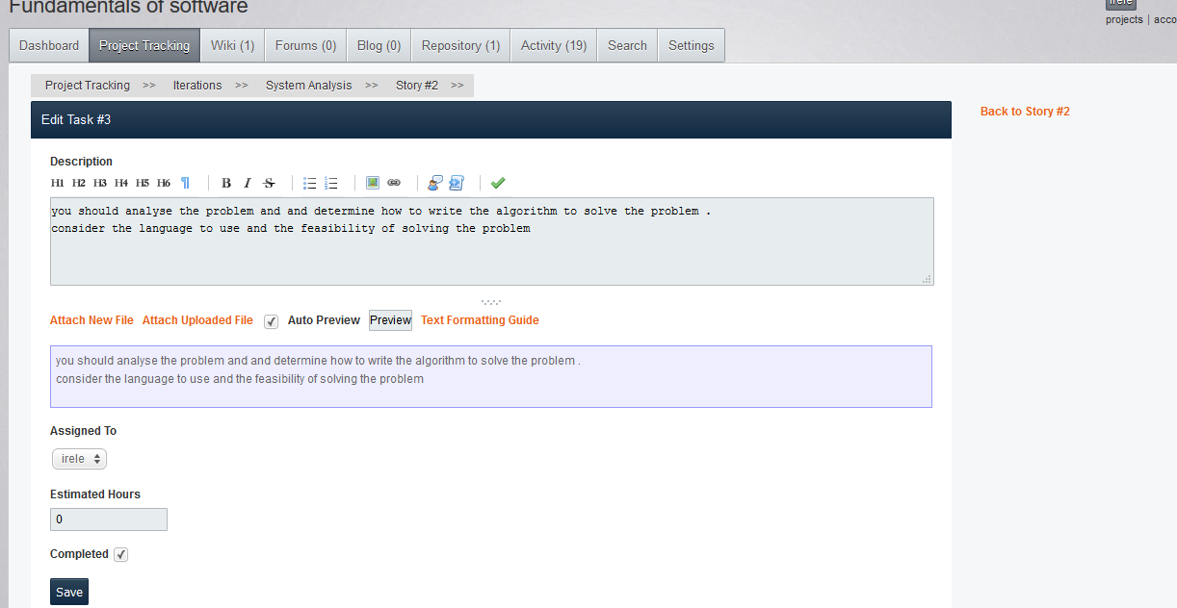

Iterations 3: coding

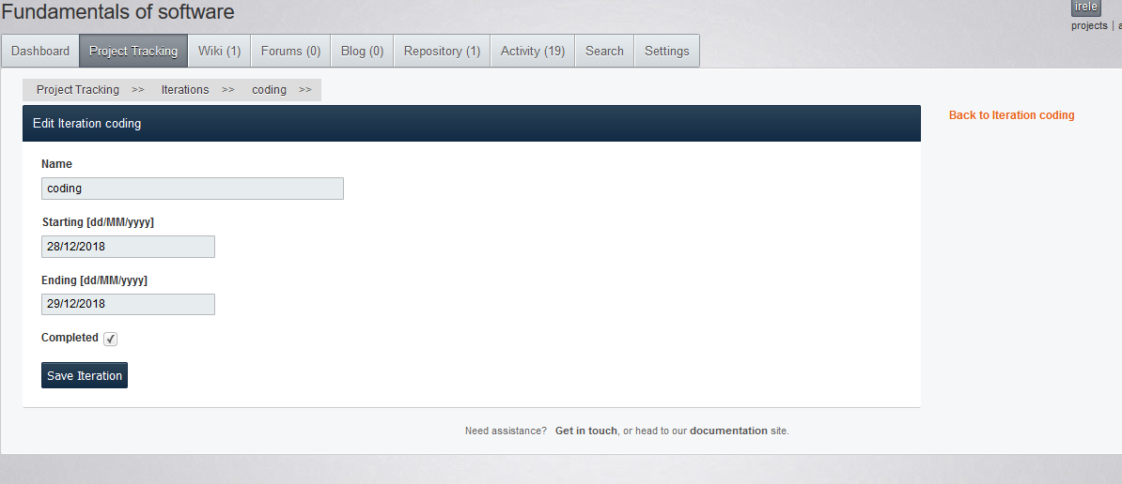

Coding Task:

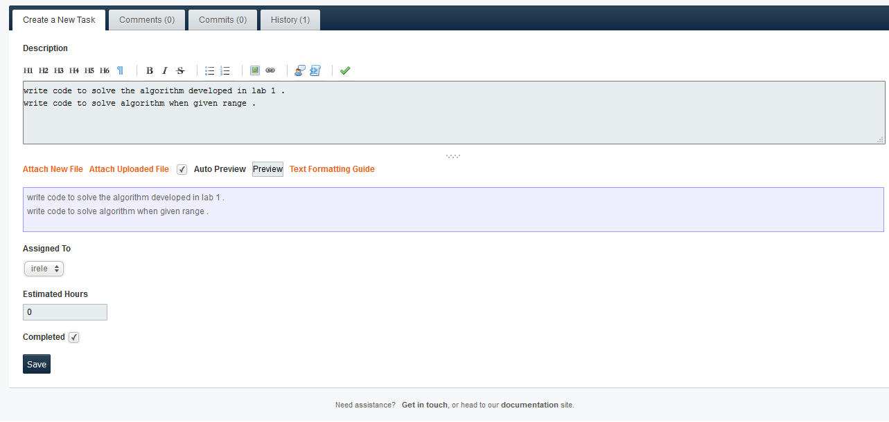

Iteration 4: Testing

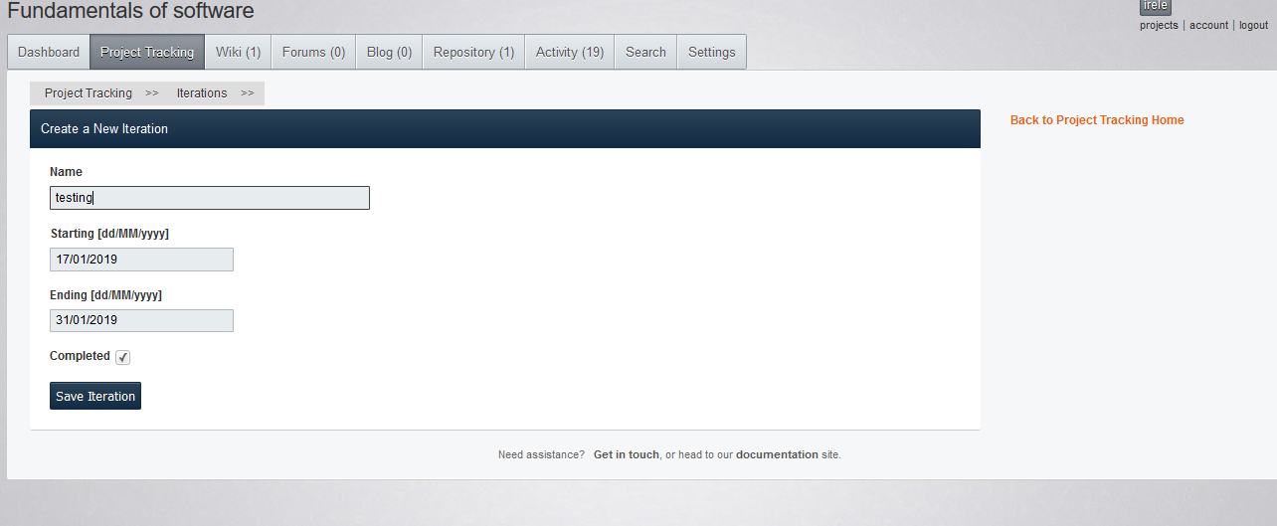

TestTask

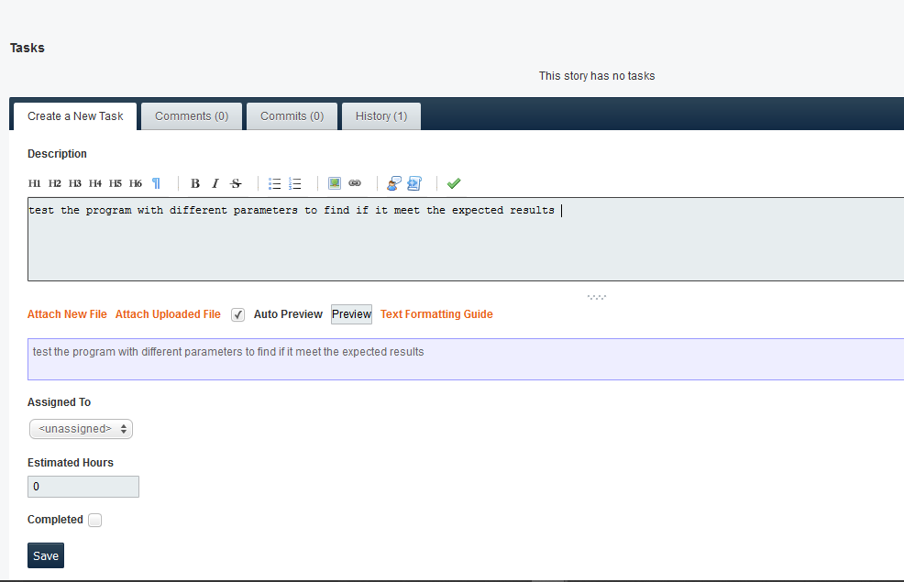

Iteration 5: implementation

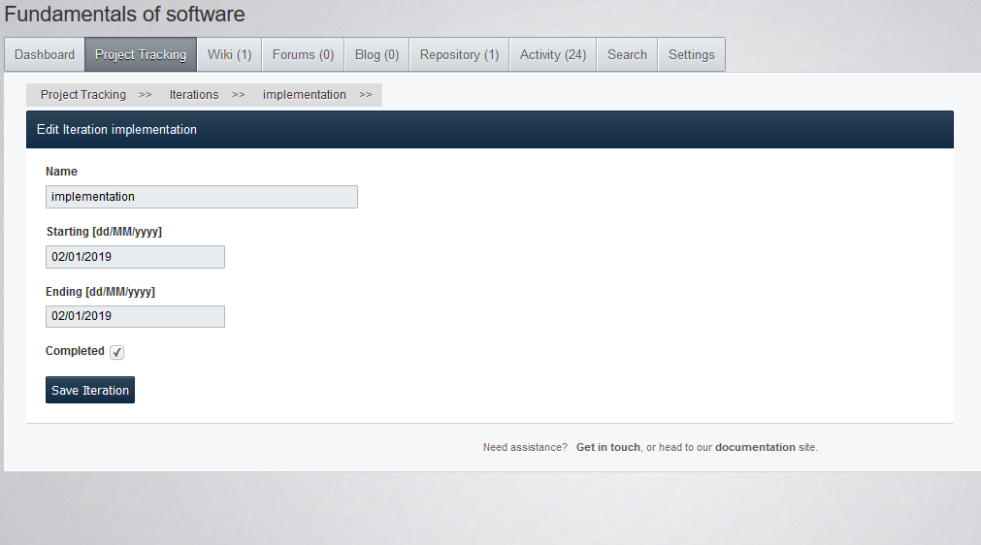

Implementation task

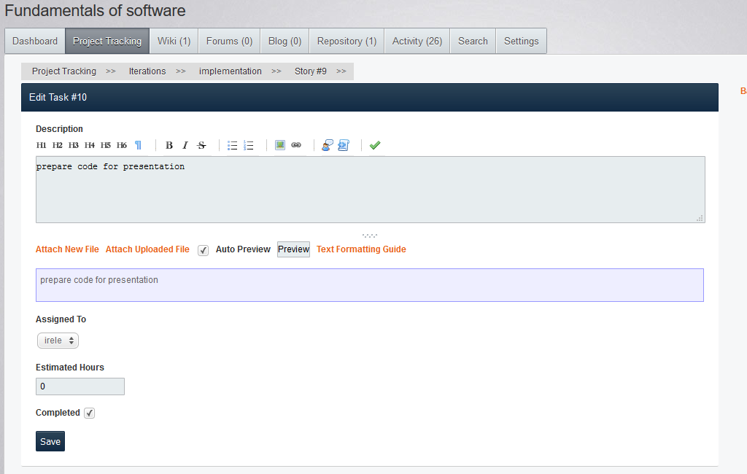

All iterations:

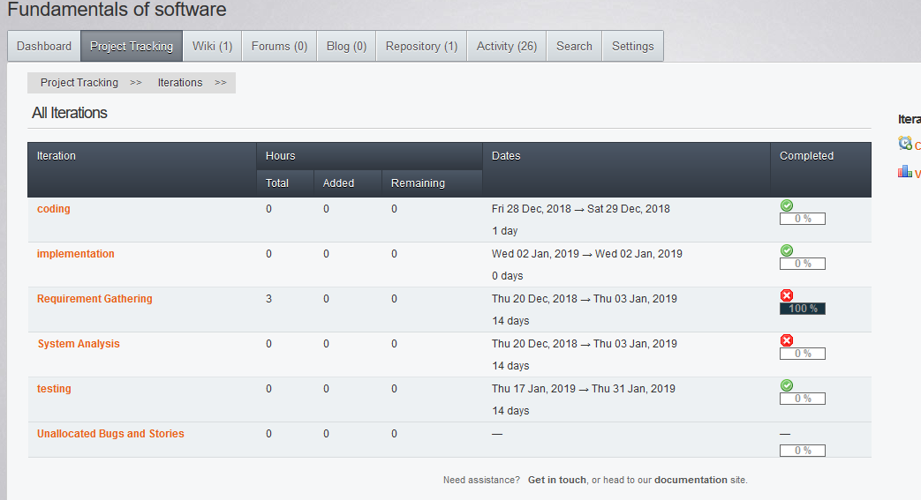

New repository:

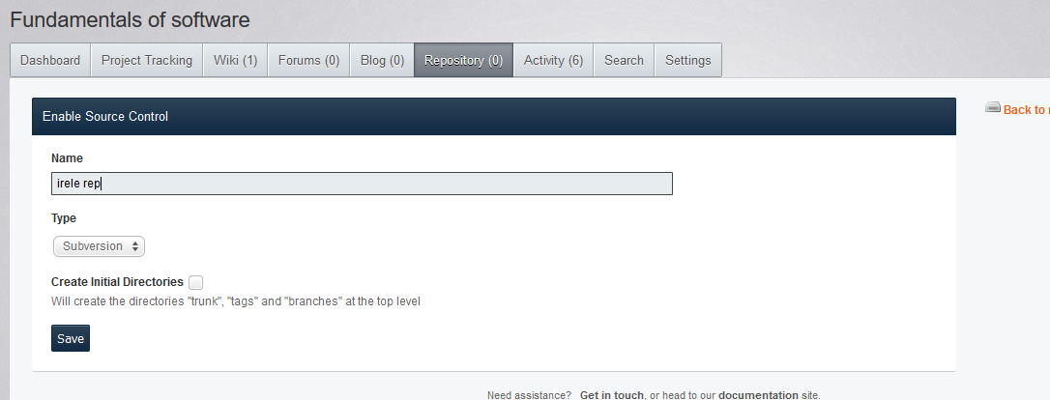

Add file:

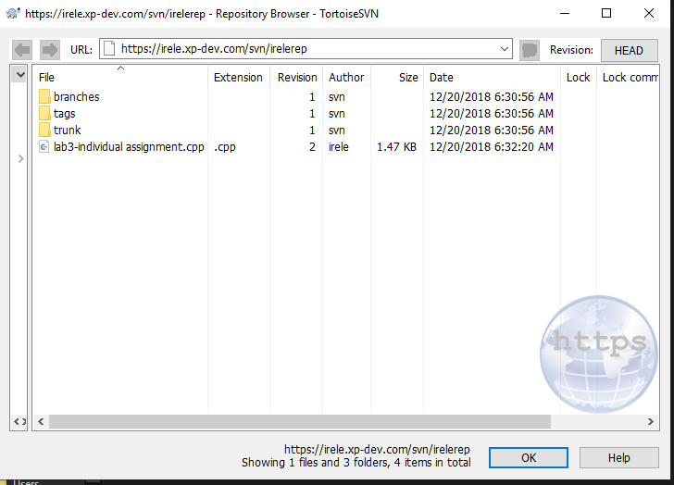

Checkout:

